Programming Assignment Unit 4

An Assignment submitted in partial fulfillment of the requirements for the degree of
Bachelor of Science
in
Computer Science

CS 2203 – Databases
Term 1 - 2025
University of The People

October 3, 2024
- Create a database schema for managing a library system with the following entities:
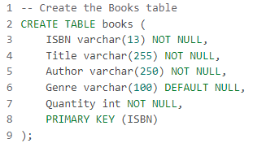
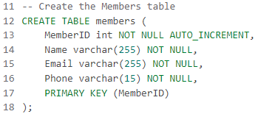
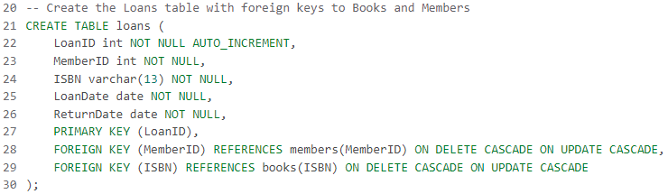
- Insert new records into the Books, Members, and Loans tables.
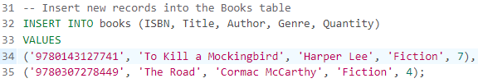
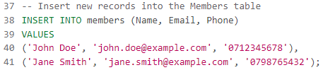
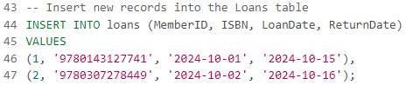
- Retrieve all information about books borrowed by a specific member.
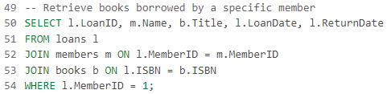
- Update the quantity of a particular book in the Books table.
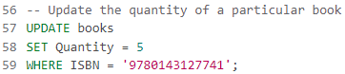
- Delete a member record from the Members table.
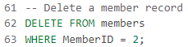
- Document your SQL script with comments to explain the purpose of each statement and provide a brief overview of the database schema.
The provided SQL script is already documented with comments explaining each step. Here's a brief overview of the schema:
- Books Table: Stores information about the books available in the library, including the book's ISBN, title, author, genre, and available quantity.
- Members Table: Stores information about library members, including their name, email, and phone number.
- Loans Table: Stores loan records that track which member borrowed which book, along with the loan and return dates. The table includes foreign keys linking to the Books and Members tables, ensuring that a loan entry corresponds to valid members and books.

